Anticipation
Recently when Portobello was covered in snow (and is forecast to be so again this winter) the words of the Victorian poet Coventry Patmore will give us encouragement as we anticipate the arrival of Spring

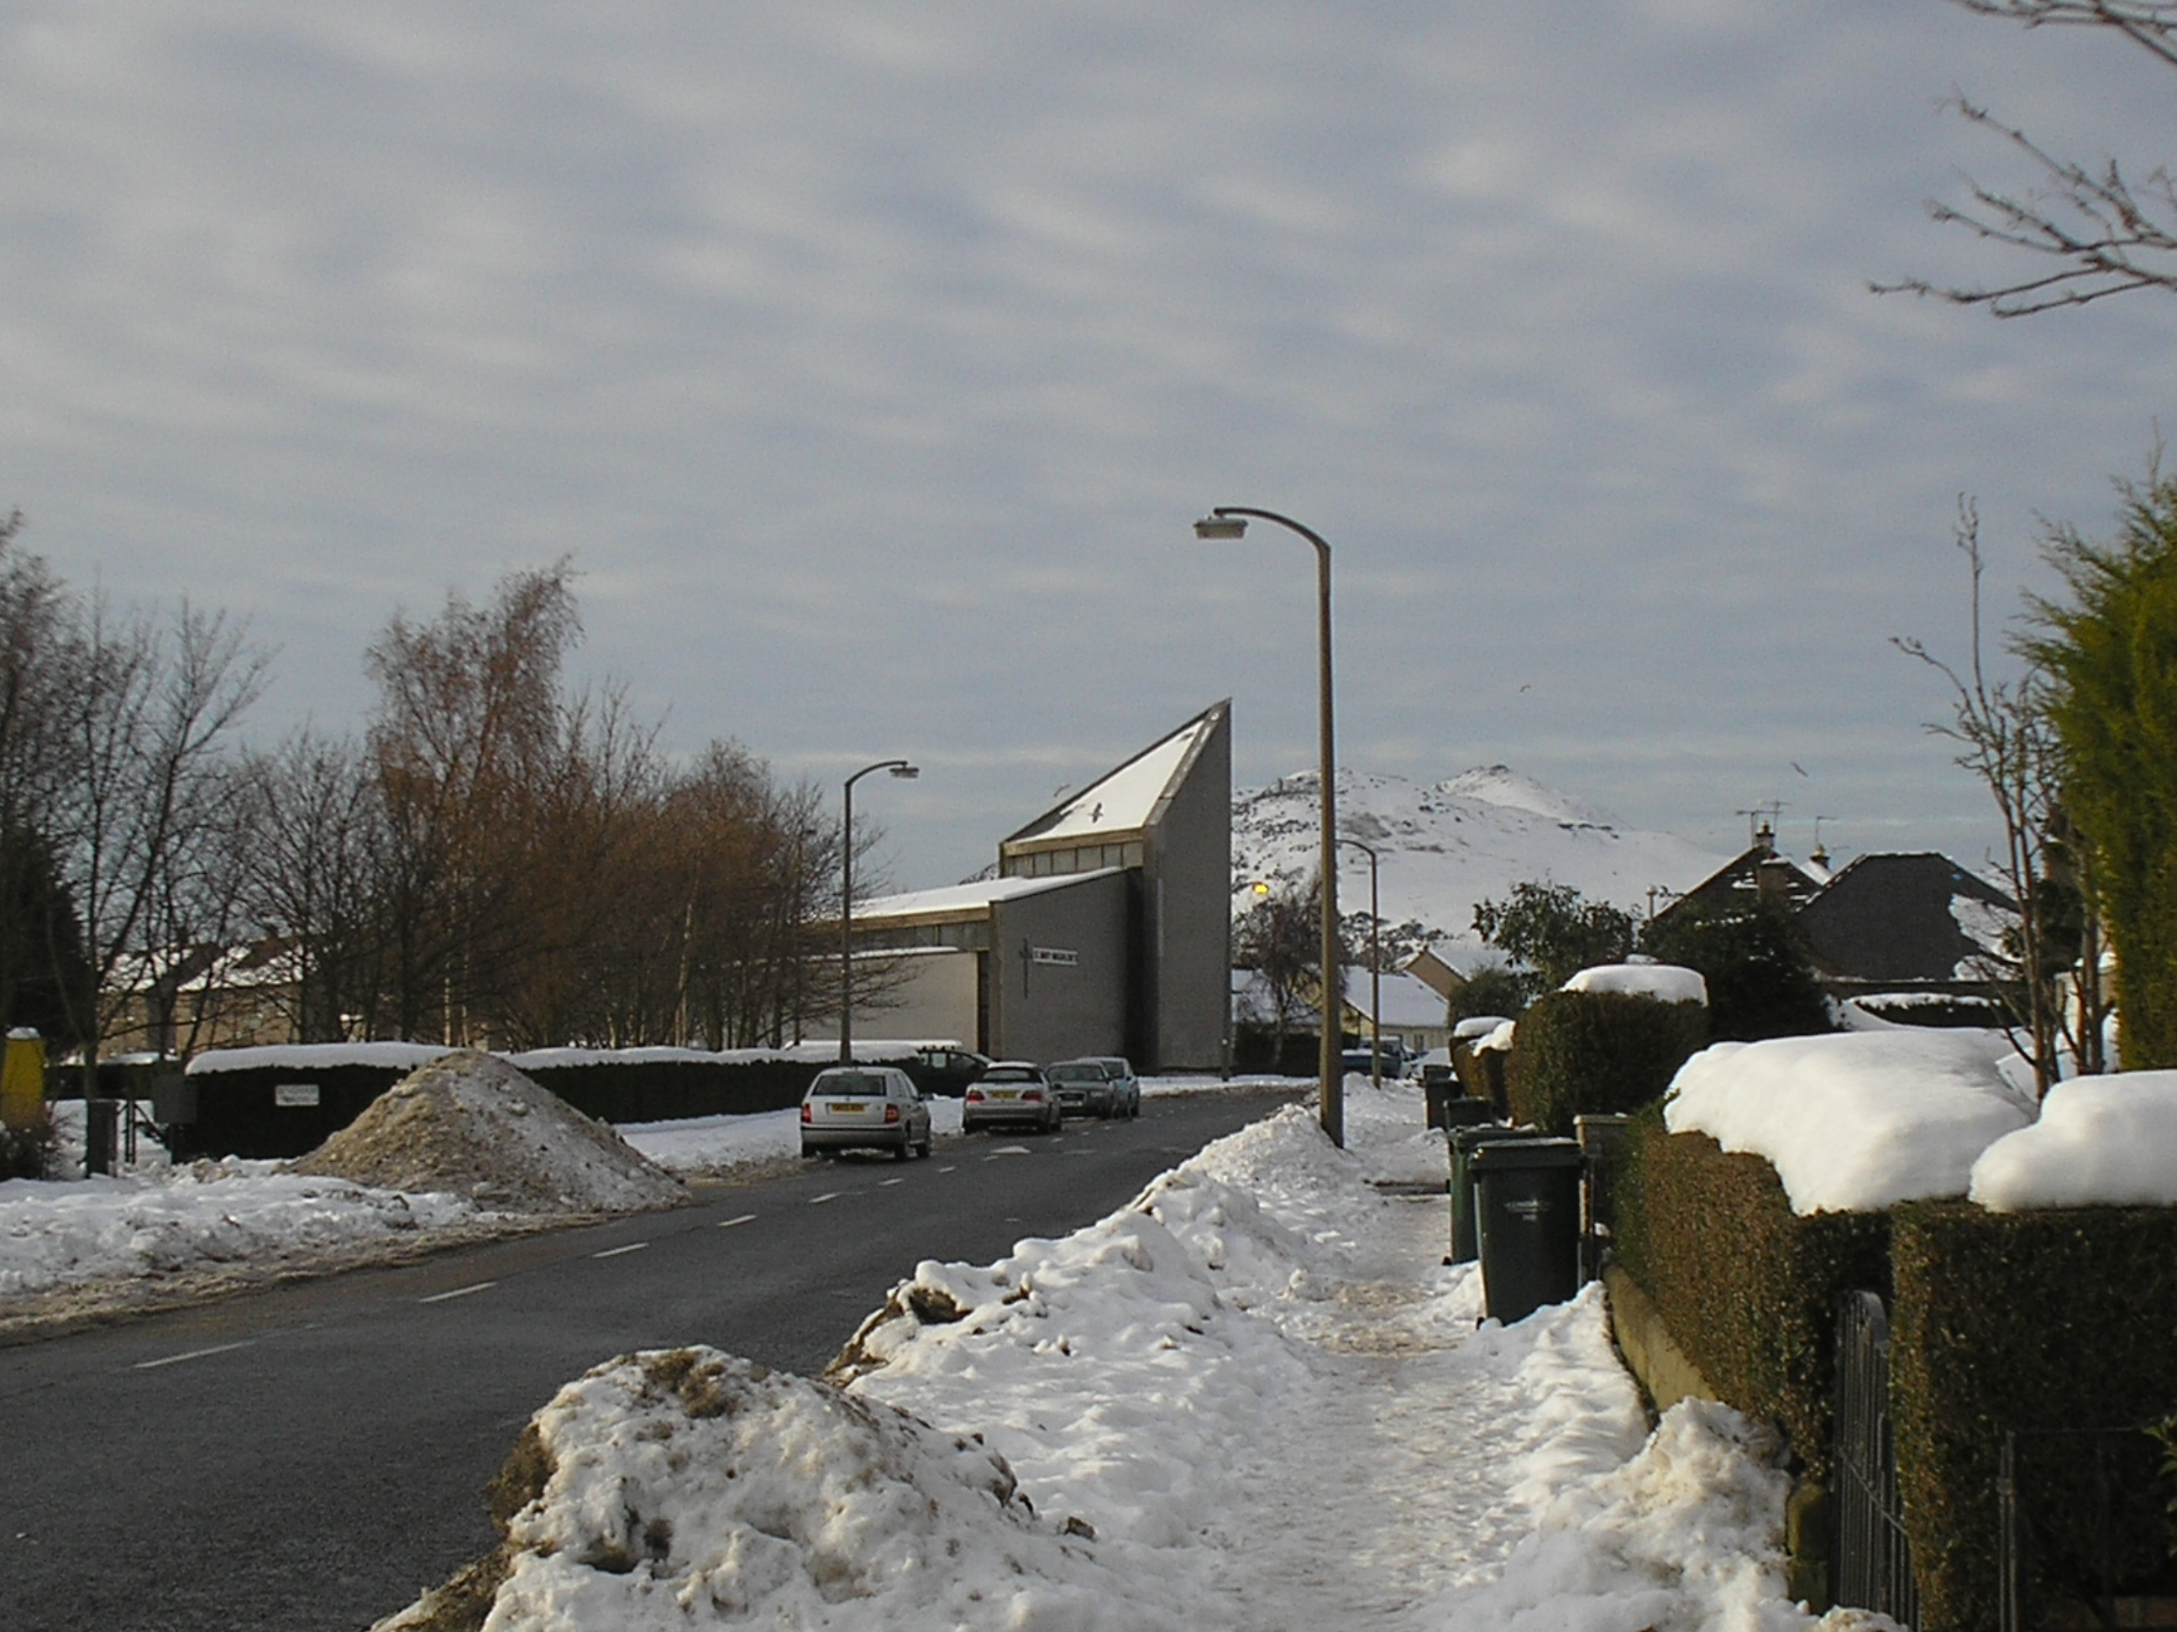
With the infant harvest breathing softly below
Its eider coverlet of snow.
Nor is in field or garden anything
But, duly look’d into, contains serene,
The substance of things hoped for in the Spring

Today’s thought.

Robinson Crusoe recalls that when he was shipwrecked and feeling very low he found among his salvage a little Bible.. He then says “I opened the Bible upon these words ‘I will never, never leave thee, nor forsake thee’. Immediately it occurred to me that these words were for me.”
And for me and for you………..

New Rotas: are now ready and are in the Porch. Will all involved please collect their copy after Mass today.
Thanks

Prayer
This is the month of the Holy Name of Jesus

St Paul said “At the name of Jesus every knee should bow, of things in heaven, and things in earth, and things under the earth; and every tongue should confess that Jesus Christ is Lord."
Very early on, Christians came to understand that the very name of Jesus had great power, and the recitation of His Name was itself a form of prayer
St. Paul urges us to "pray without ceasing," and this, The Jesus Prayer, is one of the best ways to start doing so:
“O Lord Jesus Christ, Son of God, have mercy on me, a sinner”

SMILE
A teacher asked her class “What is the plural of mice?”
Pupil: Mice
Teacher “And what is the plural of baby?”
Pupil: Twins

PUZZLE:
Three men had a meal in a restaurant and the bill came to £25. They each gave the waiter £10 and the waiter brought back their change which was £5. Then they each gave the waiter a £1 tip.
Therefore the meal cost them each £9.
3 x 9 =27 + £2 change =29.
Where is the missing pound?
Answer next week.
'I'm on my way to a lecture,' answered Daniel.
'And who on earth, in their right mind, is going to give a lecture at this time on New Year's Eve?' enquired the constable sarcastically.
'My wife,' slurred Daniel grimly

